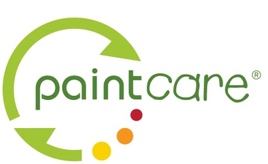 | Retailer Interest Form  To Be a PaintCare Drop-Off Location

Use this form to let us know that your store is interested in becoming a PaintCare drop-off site. PaintCare has published fact sheets for each state where we have a paint stewardship program to explain details about working with PaintCare to become a paint drop-off site. Please visit www.paintcare.org or call (855) 724-6809 to request a state-specific fact sheet.

Note: This form is designed in Word using tables. If you are using the electronic version, just start typing. The boxes will expand to fit.

Sponsor | Store Name
 | Street Address
 | City/State/Zip
 | Mail Address
 | Business Hours
Contact 1 | Name
 | Title
 | Phone
 | Email
Contact 2 | Name
 | Title
 | Phone
 | Email

Store Type |  | ☐ Independent ☐ Franchise ☐ Chain ☐ Co-op ☐ Big Box
parent |  | Fill this out if your participation is managed by a parent company:
company | Company Name
 | Contact Person
 | Phone
 | Email
storage space |  | How many cubic yard bins do you have space to store?
Each bin uses the floor space of a pallet, 3’x3’.
Normally, participating retailers are required to have at least two bins.
Storage Location |  | ☐ Indoors ☐ Outdoors (secured away from public)

Questions / Comments

Use this space to ask questions or provide additional information:
Send Completed form to |  | info@paintcare.org  (855) 385-2020 Fax  PaintCare, 901 New York Ave. NW, Washington DC 20001

